Three key factors restricting MVVM performance and corresponding solutions of QC
1.Docment operation
- Run the expression with the function ‘eval’
- Bind events

The solutions of QC
1.When the first rendering, it is very slow to create documents while rendering because of the corresponding relationships. The QC method is to generate an HTML string before rendering without generating documents. Finally, it is loaded into the page through the innerHTML. At this point, our document does not generate how we set up a two-way correspondence. At this point, QC generates a q-id for each element that needs to be manipulated.
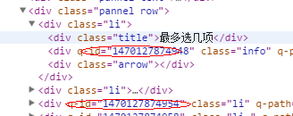
So where does this mapping table go? Because an element may bind several attributes or parent attributes like $p.xxx, how to store an object of the VM of QC is a big problem. There is a $map where the expression for all the simple attributes of the object is stored
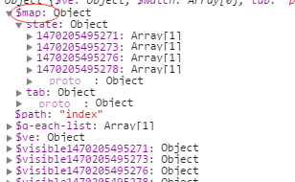
2.Intelligent completion of qc: QC traverses the binding of the page before rendering and generates a model that matches the various data in the vm. If the property is not bound to the page, then QC will not do anything based on this property to minimize useless operations if the VM does not A property QC generates this attribute on VM and assigns it to an empty string.
2 Our framework is often required to bind expressions, but the tested Eval is a performance killer if it is used to parse our expression performance will be affected, QC rewrites expression parsing, and extends the trinocular expression to accommodate multi-state binding according to the actual scenario in development
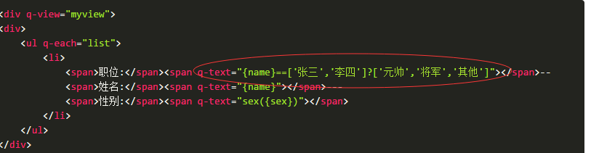

When the name is "Zhang San" is to show "Marshal" and "Li Si" is to show "General" other values is reality "other".
3.Event binding is also one of the main reasons for performance, and this scenario occurs mainly in arrays; the QC solution is that all events are bound to the parent node, a design idea derived from jQuery's event delegate and simplify custom event gestures.
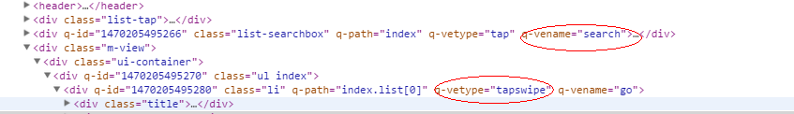
Mobile terminal tap events extended with QC event extension interface
